**ERP POINTS OF MEETING – UPDATED WITH WORKOUTS**

1. **We have to separate payroll and shifts schedule of each department**

**Workout:**

1. **When creating employee, we will add an option to select cost center.**
2. **Will create separate roles for create payroll.**
3. **The Users classifications of supervisors and head of departments.**
4. **Update the basic employees profiles as the trial user Mr Mohamed provided during the meeting**

**Workout:**

In the **employee profile**, we will have **my leave requests**, **other requests**, **my documents** Options as **tab** wise.

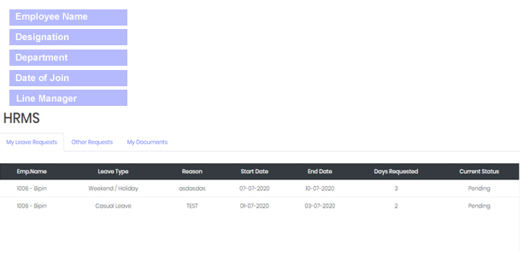

And employee will have the access for:

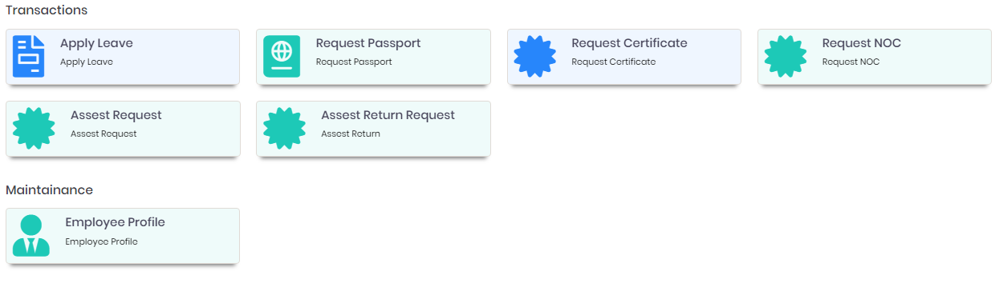

In the Leave request, we will add one extra memo or comment option for entering the **assigned task** for that employee on the leave period. Please refer the screen shot.

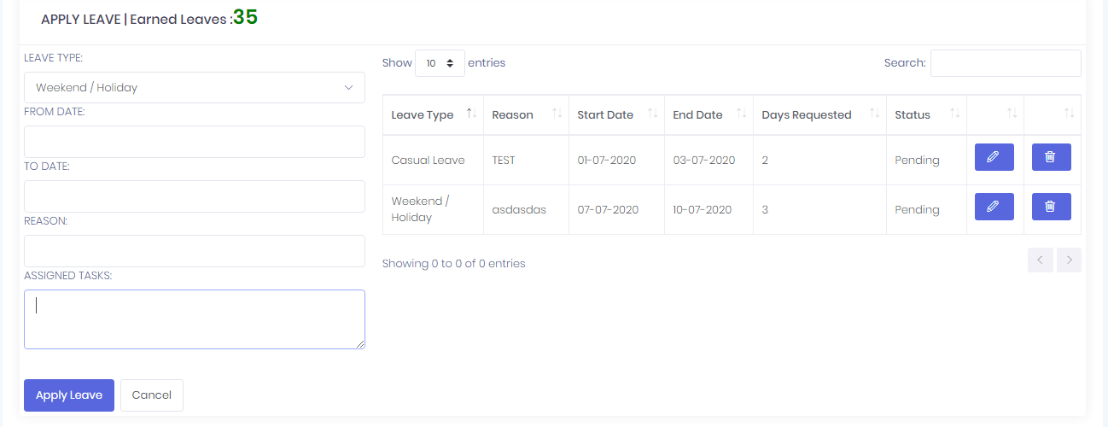

**In request passport withdrawal request form contains:**

**Passport required date, and adding option for employee comments or description.**

**In certificate request form contains:**

**Certificate type, certificate required date and adding option for employee comments or description.**

**In NOC request form contains:**

**NOC document name, required date and adding option for employee comments or description.**

**In asset request form contains:**

**Asset type, asset details entering options like model number, serial number etc., and required date and adding option for employee comments or description.**

**In asset return request form contains:**

**Requester details and adding option for comments.**

1. **Approval cycle for all the requests {Head of dept – HR-ADMIN-ACCOUNTANT depend of the request} – (Loan-leaves- NOC- salary certificates-Passport withdrawal ETC)**
2. **Adjusting the calculations of leave days as we spoke about and to use the formula which we have provided –**
3. **First 6 months there is no leave.**
4. **After completing 6 months to 11 months 2 days /month leave.**
5. **After completing 12 month , 0.5 will be added to previous 12 months**

**Kindly check the calculations method and update us if any changes required.**

1. **Salary breakdown in the payroll format**
2. **Employees documents has to be showing in they are profile and able to print**
3. **Any Rejections of requests has to be with note to submit**
4. **we have to create an adds on the setting as option for automatic payroll creation**
5. **we have to add upload option for warning letters , also for deductions and that should reflect on the payroll and share notifications of employees profile and emails**
6. **The deductions should not be more than 10% and in case more than that , the system will record that and spread it on the next month payroll .**
7. **Payroll calculations will be from 20 to 19Th of the month**
8. **Have a link on the side of employee profile regarding the polices and code of conduct**
9. **Admin Category should be created and to add some of the requests under it –**

**Need clarifications on this**